Modified Naive Bayes Model for improved Web Page classification
Faiyaz Ahmad | Hammad Haleem | Akshay Kumar | Niyas C
ahmad.faiyaz@gmail.com | hammadhaleem@gmail.com | akshay061@gmail.com | niyasmonc@gmail.com

Department of Computer Engineering, Faculty of Engineering and Technology,
Jamia Millia Islamia
New Delhi 110025, INDIA

Abstract—World Wide Web is a large repository of information and it keeps on growing exponentially. The fact is that most of the information stored in it is in either unstructured or semi structured way. So it is not that much easy to get desired piece of information out of that large collection of unprocessed data. Several strategies has been employed to mine the data in World Wide Web for finding interesting information and to organize them in a meaningful way. Web data mining is a field of active research interest and computer scientists across the world is looking into development and improvement of web mining strategies. In this paper we will present a modified probabilistic model based on naive bayes theorem, which will help to classify webpages based on their textual content, in a better way than traditional naive bayes model.
Key words : Text classification, Machine learning, Naïve Bayesian, Web-mining, Probabilistic models, Webpage classification.

Introduction
The World Wide Web (WWW) has shown an exponential growth within last two decades in terms both technology involved and amount of information stored in it. It is observed that 90% of data in internet is generated within last two years[1]. According to google indexing, there are around 20 billion web pages on this very day[2]. Now around 2.4 billion people are depending internet for finding information. Out of these people 70% use internet every day. And there was a rise in number of internet users by 566% percentage from 2000 onwards[3]. Today internet is a major source of information. But the problem is that whole content in internet is stored in an unstructured way. We have to dive ourselves into heap of data in order pick out relevant piece of information. Luckily today we have several different tools available for picking out the relevant piece of information from internet. These tools can be broadly classified as 1.Crawler based Search Engines (SE) e.g., Google, Bing, Yahoo, Duck-Duck-Go etc., 2.Meta Search engines e.g. Metacrawler, Clusty etc. and 3.Subject Directories like DMOZ (Directory Mozilla), Librarians Internet Index (LII) etc. The crawler based search engines and subject directories maintain their own data repositories, whereas meta search engines don’t maintain any such data repositories, instead they depend on indices of other Search engines and subject directories to answer user queries. The database maintained by any crawler based search engine is quite large, and have considerably larger amount of data indexed in their databases as compared with subject directories[4].

In this paper we use a probabilistic model based on Naive Bayes theorom. Naive Bayes model is a straight forward and frequently used model for supervised learning. It provides a flexible way for dealing with any number of attributes and classes. And also there is less effect of noise and can be easily scaled into large amount data without much rise in time as compared to other algorithms. And the probabilistic model that we used in this paper based on naive bayes theorem was able to provide an accuracy around 94% for the given data set.

The rest of the paper is organized as follows. Section II reviews previous work on the machine learning, classification and probabilistic approaches. Section III and IV discusses the classification of web pages and Naïve Bayes Theorem respectively, Section V presents our approach of classifying webpages based on textual content of web pages using NB technique. Section VI discusses the results of our experiment. The last section summarizes the paper and gives some directions for future research.

Related Work
In this section we briefly try to review previous works in the field of text classification with a special emphasis on classification of webpages. In the early days, classification was done manually by domain experts. But very soon, classification was also carried out in semi-automatic or automatic manner[4]. In previous decades several studies have undergone about text classification. The major method proposed for text classification includes decision tree method[5], rule based classification method[6], SVM(Space Vector Model) classification[7][8][9], Neural network classifiers[10][11][12], Bayesian classifiers[13][14], k-nearest neighbour approach[16] and also there are some other classifiers which do not belong to above categories[15]. Most of these base methods were further extended for classification of web pages by taking textual content or hierarchy of web page into consideration[17]. Among available classification methods, decision trees were selected for their simplicity and intuitiveness. Decision trees were developed using WEKA [18], (Waikato Environment for Knowledge Analysis) a collection of machine learning algorithms for data mining tasks. Shanks et. Al [19] have used the first fragment of each document to classify news articles. This approach is based on the assumption that a summary is present at the beginning of each document, which is true only for news articles, this approach was later applied to hierarchical classification of web pages by Wibowo et.al [20]. Some approaches were also introduced on the basis of links present in the webpage and analyzing target pages[21]. Another variation of same was proposed in which only some of the target pages are taken into consideration[22]. There are numerous other models proposed which classify web pages into different categories based on their content hierarchy. Some of them classify webpages into two categories while others classify into multiple categories.

Classification of Web pages
Web page classification is different from normal text classification in some aspects. The uncontrolled nature of web content presents additional challenges to web page classification than traditional text classification. The web content is semi structured and contains formatting information in form of HTML tags along with CSS and javascript content. Also web page may contain hyperlinks to provide link to other pages. This interconnected nature of web pages provides features that can be of greater help in classification. Prior to classification of web pages, we perform pre-processing of it's contents. First step of pre processing is removal of CSS and javascript contents. Then some features are extracted from html tags if any. After that html tags are also removed which will result in a pure text document and remaining steps will be as per traditional text classification method. Text document is divided into list of words after eliminating all punctuation marks, numbers and non-ascii characters assuming that we are classifying english documents only. In next step we remove stop words which are the words that commonly come in all categories. After that, words are normalized(converted either to capital or small) and then a stemming algorithm is applied on them. One such frequently used stemmer is the Porter’s stemming algorithm [23]. Each text document obtained by application of procedures discussed above is represented as frequency vector. Machine learning algorithms are then applied on such vector for the purpose of training the respective classifier. The classifier is then used to test an unlabeled set of test documents and it is ensured that, it has enough accuracy for using on previously unseen documents.

Bayes Algorithm

Bayesian Classifiers:
Bayesian classifiers are statistical classifiers which predict the class membership probabilities of tuples. It means probability of a given tuple to be in a particular class. Bayesian classifiers are based on Bayes theorem which will be explained in next section. Studies comparing classification algorithms have found that a simple Bayesian classifier known as the naive Bayesian classifier is comparable in performance with decision tree and selected neural network classifiers. Bayesian classifiers have also exhibited high accuracy and speed when applied to large databases. In theory Bayesian classifiers have the minimum error rate in comparison to all other classifiers. However, in practice this is not always the case owing to inaccuracies in the assumptions made for its use, such as class-conditional independence, and the lack of available probability data. [31]

Bayes Theorem
This theorem was named after Thomas Bayes who did early work in probability and decision theory during the 18th century. Let X be a data tuple. In Bayesian terminology, X is termed as 'evidence'. X is described by an attribute vector consisiting of n attributes. Ie, X={x₁,x₂,x₃....x_{n}}. Let H be some hypothesis that the data tuple X belongs to a particular class C. For classification problems we want to find P(H|X), the probability that hypothesis H holds when attributes set/'evidence' X is given. That means we are looking for the probability that the tuple X belongs to class C, given that we know the attribute description of X. Bayes theorem helps us to determine the probability P(H/X) in terms of P(H),P(X/H) and P(X).

Bayes Theorem is:

--(1)

Where P(X/H) gives the probability for tuple to occur when it is given that the hypothesis holds. P (H) is the probability for the hypothesis H to hold. And P(X) is the probability for the attribute set X to occur.

Naive Bayes Classifier
Naive Bayes Classifiers are Bayesian Classifiers which assume class conditional independence. I.e., it assumes that the effect of an attribute value on a given class is independent of the values of the other attributes. This assumption simplifies the calculations a lot. Naive Bayesian classifier works as follows.

Let D be a set of tuples and their associated class labels. Each tuple is represented by n dimensional attribute vector in the form (x₁,x₂,x₃....x_{n}) depicting n measurements made on the tuple from n attributes, respectively, A₁, A₂,A₃...A_{n}
Then

--(2)

As P(X) will be constant for all classes, we have to consider numerator term only. If we are taking equal number of training tuples for each class, then P(C_{i}) will be same for all classes. In such cases we have to maximize P(X/C_{i}) only. Otherwise we have to maximize P(X/C_{i})*P(C_{i}). Where P(C_{i}) can be calculated as follows)

--(3)

When we have data sets with several number of attributes, it is computationally expensive to calculated P(X/Ci). But when we assume class conditional independence, computational cost can be reduced significantly. With this assumption P(X/Ci) can be calculated as follows.

ie,

--(4)

If attribute A_{k} is categorical, then P (x_{k}/C_{i}) is given as follows

--(5)

If attribute x_{k} is continuous valued, then the following function can be used for finding P(x_{k}/C_{i})

--(6)

So that:

--(7)

To predict the class label of X, P(X/C_{i})P(C_{i}) is evaluated for each class C_{i}. The classifier predicts that the class label of tuple X is the class C_{i} if and only if P(C_{i}/X) > P(Cj/X) for 1 <= j <= m and i!=j

Modification on Naive Bayes Model for Document Classification
For document classification problems calculation of P(x_{k}/Ci) will be modified. It is required since attributes are not either categorical or continuous valued in case of document classification problems. In document classification problem we have the relation,

--(8)

Where n_{d} is number of tuples in class C_{i}. P (t_{k}/C_{i}) can be calculated as follows:

--(9)

Where T_{ci} is number of occurrences of word T_{k} in category C_{i}. V is the vocabulary, all words in training set.

Proposed Modification
In proposed model, we do not multiply inidividual probabilities together , instead we add them up to produce final probability. Experiment performed for this paper shows that adding individual probabilities together will provide better result than multiplying them together.
ie, equation 8 will turn to

--(10)

Laplacian correction:
To avoid zero computational value In order to avoid the zero probability value , when a word in testing tuple do not come in training set, we use Laplacian correction. Laplacian corrected formula is Where V is number of terms in vocabulary.

--(11)

Experimental Setup
This section explains the setup of the entire experiment. We collected different web pages belonging to predefined categories. Then popular data cleaning and data extraction techniques were applied to extract useful data from collection of webpages. Once the data extraction process is finished we trained our classifier and used k-fold strategy and random sub sampling method to decide the accuracy of classifier. All the processes are briefly discussed below.

Data Set
Standard 20 newsgroup data set was used for experimental purpose. This dataset contains 19997 documents classified into 20 different groups uniformly.[add more detail and reference]

Cleaning HTML Documents
We used the Python3 regular expression module and BeautifulSoup module to extract the information from web pages. Beautiful Soup is a Python library designed for easy and effective scraping of webpages and provides a few simple methods and Pythonic idioms for navigating, searching, and modifying a parse tree [24]. Rather than extracting information from specific tags we removed all the HTML tags present in the document with the exception of title tag because it offers considerable amount of information regarding the category of webpage.

All non ASCII characters, special symbols and numbers were removed from the data. CSS and JavaScript content present in the HTML documents were also cleaned during this phase. In many webpages images were used as in place of hyperlinks or images were used to display some important information. Such information is a very important feature for classification purpose, however our experiment concentrates on text based retrieval so such graphical contents were ignored. The standard Stop-Word list used in Bow [27] was used along with a comprehensive Stop-word list provided In the NLTK[28] (Natural language processing toolkit) library in python. Along this we used the Porter stemming[25] technique to reduce words to their least forms. Porter's stemmer provided in NLTK library was used for stemming purpose. After all the above processing the HTML document was converted into a list of words in their most basic forms. All words having length less than 3 were removed. Further these words were converted into lowercase and then they were stored in a hash table along with their respective frequencies. All words having frequency less than 2 were ignored.
The whole process of web page cleaning can be described by following algorithm.
Algorithm 1
Algorithm for getting data out of a web document in required form
INPUT:
filename->name of input file
OUTPUT:
freq-> Hash table containing frequency list of relevant words in given web page.
Function preprocess(filename):
data=content_of(“filename”)
pure_text=remove_html_tags(data)
text=replace_nonascii_digitis_with_space(pure_text)
text=replace_special_symbols_with_space(text)
words=split_words_by_space(text)
words=convert_to_lower(words)
words=lemming_and_stemming(words)
words=remove_stop_words(words)
words=remove_words_with_length_lessthan3(words)
freq=count_freq_of_words(words)

return freq

Vocabulary Generation
Following algorithm was used for vocabulary generation
Algorithm 2
Algorithm for vocabulary generation
INPUT:
train_set->set of training documents in the format {name,category}
categories->A list containing available categories
OUTPUT:
database-> a 2d hash array listing frequency of each word in each category
Function vocabulary_generation(train_set)

database={} // define database as a hash function

for each category in categories:
database[category]={} //define each item in database
//as hash function

for each document in train_set:
freq=preprocess(document.name)
for each word in freq:
if word in database[document.category]:
database[document.category][word]+=freq[word]
else:
database[document.category][word]=freq[word]

return database

The words that occurred commonly in most of the webpages were considered as stop words. A list of such words is present in Table 1.
- Web-page specific stop words
Home, mail, email, contact, sitemap, admin, login, signup, rights, reserved, copyright, designed, search, about

These common words were considered as Stop-Words and removed directly from the document. It was also observed that webmasters inflated the title, Meta description and keyword tags with multiple keywords. We normalized such repeating keywords to reduce the impact of site promotion techniques applied by webmasters. This step was performed during the cleaning phase. All the words with the occurrence less than two were removed from the Documents and also the words with length less than three were also discarded from the Data. The frequency of each of the words was stored in a Hash table along with their category, for faster and efficient access in the later stages of experiment. The keywords that appear in two sample categories are given in table II and table III

- Key words Related to 'alt.atheism'
Convert morally santa practice natheism believe worship violence punisher war death law oppress divine punishment christ reality fatwa bible muslim communist religion morality light satanic sacred evolution christanity holy patience peace sincere
- Keywords Related to 'sci.electronics'
Copper filter active technology packard communication eng circuit logic pulse electronic button circuit frequency encryption storage system electrolyte output channel chip nand neutral printer modem signal battery standard voltage machine hewlett assembler program

Testing and Training the Classifier
For testing the efficiency of classifier, we used two strategies namely k-fold cross validation strategy and random sub sampling method. We used k fold strategy for the values of k ranging from 2 to 10. In this method documents in each category will be divided into k equal partitions say D₁, D₂, D₃... D_{k}. Training and testing will be performed k times. In iteration i, partition Di in each category will be reserved as a testing set, and the remaining partitions will be collectively used to train the model. That is, in the first iteration, subsets D₂... D_{k} collectively serve as the training set to obtain a first model, which will be tested on D₁ of each category; the second iteration will be trained on sets D₁, D₃... D_{k} and will be tested on D₂. And so on. In random sub sampling method we randomly pick k number of documents as training documents and remaining documents will be used for testing. And this procedure will be repeated n times. Overall accuracy will be average of accuracy values obtained each time.

Prior probability of each category will be same since we have taken equal number of documents in each category. Training set was stored in the form of hash tables of hash tables. Each hash table in first level stands for category. And hash tables in second level will be containing the frequency of words in that particular category. The posterior probability with Laplace’s correction was calculated using the formula[26][31]:

P (wk/C) = (n_{k}+1) / (n + |Vocabulary|) --(12)

Where n_{k} stands for number of occurrences of word W_{k} in category C, N is total number of words in given category and |vocabulary| stands for number of words in training set. In order to classify a document say X, the probabilities of each word of document in a given category were calculated from hash table , then they were added together to obtain final probability . Then category of a document will be decided as follows

C=Ci where P(Ci/X) is maximum --(13)

The calculated values were compared to find the maximum of all. The category with maximum relative probability was selected as the class for a document. The equation 13 helps to clearly understand the solution of the mentioned problem. The Proposed algorithm for deciding the category of a webpage is given as follows:

Algorithm 3
Proposed algorithm for webpage classification
INPUT
freq-> word frequency list of test web page.
Database-> 2d hash table containing list of word frequencies in each category
categories->List of available categories for classification
OUTPUT
category->category of given web page
probability_model(freq_list,database):
v=total_number_words_in_database
pc={}

for category in categories:
attributes=database[category]
n=total_number_of_words_in_category

pc[category]=0
for word in freq_list:
if word not in attributes:
pc[category]=pc[category]+(1.0/(n+v))
else:
pc[category]=pc[category] +
((1+attributes[word])/(n+v))
Category=category for which pc[category] is maximum
return Category
The result obtained from both k-fold cross validation strategy and random sub sampling method was plotted in graph format using python module pylab which is defined in matplotlib library[29].

Experimental Results
The classification task was performed for the 20 newsgroup dataset which has 19997 documents uniformly distributed in 20 different categories. In k-fold cross validation strategy we used the value of k ranging from 2 to 10. The result obtained in this phase is given in table IV and is depicted in Graph 1.
- Classification accuracy K-fold cross validation
Number of Folds k | Accuracy with traditional model | Accuracy with proposed model
2
3
4
5
6
7
8
9
10

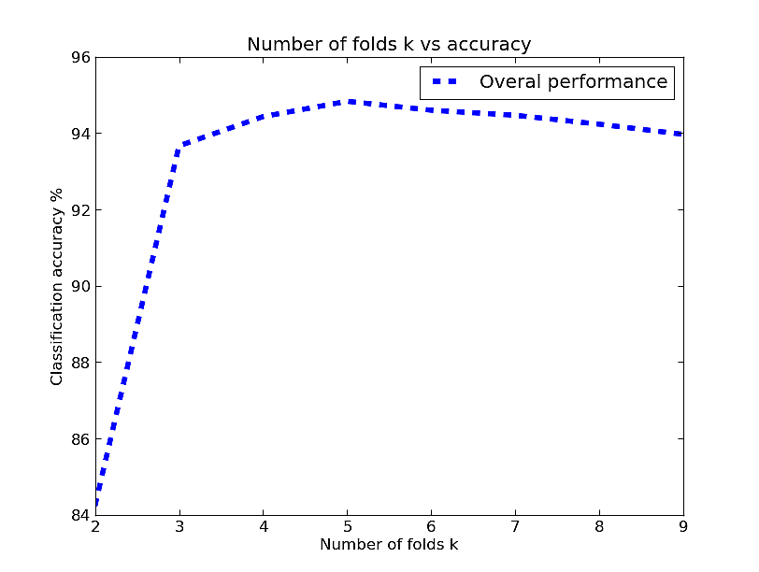
Graph 1
Average accuracy vs. number of folds

From the graph it is evident that for both traditional naive bayes model and new proposed model in this paper, classification accuracy increases with rise in number of folds of k. It is also clear that newly proposed model give better accuracy than the traditional naive bayes model.
In random sub sampling method, we used values of k in the range 100 to 1000 with an interval of 100. For each value of k, sampling was performed 3 times and the average accuracy is considered. The result obtained after performing random sub sampling method is given in table V and is depicted in Graph 2.
- Classification accuracy Random Subset Sampling
Number of training documents | Accuracy with traditional model | Accuracy with proposed model
100 | 68.63 | 68.96
200 | 74.52 | 75.04
300 | 77.78 | 78.66
400 | 79.10 | 80.28
500 | 80.23 | 81.46
600 | 81.61 | 82.62
700 | 82.25 | 83.41
800 | 83.06 | 83.93
900 | 82.91 | 84.36

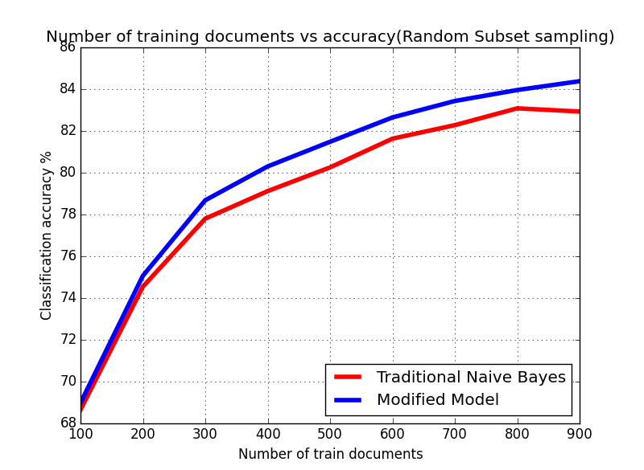
Graph 2
Number of training documents vs accuracy

In this graph classification accuracy rises with increase in number of training documents for both traditional naive bayes model and newly proposed model. Initially newly proposed model give almost similar accuracy as that of naive bayes model. But as number of training documents increases number newly proposed model get a clear domination of traditional model.

VII. Conclusion and Future Works
The proposed modification for traditional naive bayes web page classification gives better result than the traditional model. And also reduces computational cost and time by replacing floating point multiplication operations with cheaper floating point additions. We were able to get an accuracy of 84.36% for a complicated dataset like 20 newsgroup. It shows that it can perform better when we have broadly disitinct categories. This result is quite encouraging and it will help for improving the performance of web page classifiers. This approach can be utilized by the search engines and other online directory projects like DMOZ[32], Yahoo Directory for effective categorization of web pages to build a web directory with reduced human effort. This method can also be used in automatic crawlers for collecting web pages related to a particular category without human intervention.

References
- http://www.sciencedaily.com/releases/2013/05/130522085217.htm
- http://www.worldwidewebsize.com/
- http://www.thecultureist.com/2013/05/09/how-many-people-use-the-internet-more-than-2-billion-infographic/
- Automated Classification of Web Sites using Naive Bayesina Algorithm. Ajay S. Patil and B.V Pawar IMECS 2012.
- A decision-tree-based symbolic rule induction system for text categorization. DE. Johnson, FJ Oles, T Zhang, T Goets 2002
- Automated learning of decision rules for text categorization. Chidanand and Fred Damerau ACM 1994
- A statistical learning model of Text classification for Support Vector Machines. Thorsten Joachims ACM 2001
- Text categorization with support vector machines: Learning with many relevant features. Thorsten Joachims
- Support vector machines for text categorization. A. Basu, C. Watters, and M. Shepherd IEEE 2002
- Automated text classification using a dynamic artificial neural network model M. Ghiassi,M. Olschimke, B.Moon,P. Arnaudo Elsevier 2012
- Study a text classification method based on neural network model Jian Chen,Hailan Pan, Qinyum Ao Springer 2012
- Autmatic text classification using artificial neural network. Springer volume 172 2005
- Naive Bayes text classificaton - http://nlp.stanford.edu/IR-book/html/htmledition/naive-bayes-text-classification-1.html
- Naive Bayesian text classification - John Graham-cuming 2005
- A survey of text classification algorithms – Charu C Aggarwal, ChengXiang Zhai
- An improved K-nearest neighbour algorithm for text categorization. Li Baoli, Yu Shiven, Lu Qin ICCPOL 2003
- Recent research in web page classification-A review . Alamelu Mangai, Santhosh Kumar, Sugumaran IJCET 2010
- Data Mining: Practical machine learning tools and techniques, Ian H. Witten and Eibe Frank 2nd Edition, Morgan Kaufmann, San Francisco, 2005.
- Fast categorizations of large document collections Shanks, V. and H. E. Williams. SPIRE 2001
- Simple and accurate feature selection for hierarchical categorization. Wibowo, W. and H. E.Williams. ACM 2002
- Computational Approaches to Analyzing Weblogs- Mihalcea, R. and H. Liu. A corpus-based approach to finding happiness. In N.
Nicolov, F. Salvetti, M. Liberman, and J. H. Martin (Eds.) AAAI 2006
- Graph-based text classification: Learn from your neighbors Angelova, R. and G. Weikum SIGIR 2006
- S. Dumais and H. Chen, “Hierarchical classification of web content”, in Proc. of the 23rd annual Int. ACM SIGIR Conf. on Research and Development in Information Retrieval, Athens, Greece, 2000, pp. 256 - 263. [23] M.F. Porter, “An algorithm for suffix stripping”, Program, Vo.14, no. 3, pp. 130-137, Jul. 1980.
- Python beautiful soup library.
- http://www.crummy.com/software/BeautifulSoup/
- http://tartarus.org/martin/PorterStemmer/index.html Porter Stemming algorithm, with various implementations.
- http://nlp.stanford.edu/IR-book/html/htmledition/naive-bayes-text-classification-1.html Stanford NLP , naïve bayes text classification
- The BOW or libbow C Library [Online].
- Available: http://www.cs.cmu.edu/~mccallum/bow/
- Bird, Steven, Edward Loper and Ewan Klein (2009). Natural Language Processing with Python. O’Reilly Media Inc. Python NLTK
- www.matplotlib.org Python based open source mathematical analysis toolkit.
- T. M Mitchell. (1997). Machine Learning McGraw-Hill Companies, Inc.
- Data Mining concepts and techniques Han Kamber Lee Morgan Kaufman publications. 3rd Edition 2012.
- DMOZ open directory project. [Online]. Available: http://dmoz.org/

